2nd Annual BBQ Battle for Life

September 10, 2022

FOOD VENDOR REGISTRATION INFORMATION
Food Vendor Fee is $50.00
(Additional percentage may be donated to suicide prevention for tax purposes)

The 2nd Annual BBQ Battle for Life Competition will take place on September 10, 2022, at the Greenway at Ash Street in Piedmont, Missouri at 11am.

If you would like to reserve a food vendor spot, please complete the enclosed form, and mail it along with the vendor fee and certificate of liability insurance to the Piedmont Area Chamber of Commerce, PO Box 101, Piedmont, MO 63957.

Reservations will be accepted until all vendor spots are full. This is a rain or shine event. There will be no reimbursement for cancellations requested after Thursday September 1st.

Set up on Saturday, September 10th must be before 9:00 am. Food vendors may set up on Friday, September 9th if prior arrangements are made. Volunteers will be there to assist you to your location.

* A Certificate of Liability Insurance form must be submitted with this application unless other arrangements are approved. Forms must be in our office prior to set up and can be emailed to: chamberofcommerce@boycomonline.com.

If you have any questions or concerns, please contact:
Sara Phillips at the Chamber of Commerce office at 573-223-4046
chamberofcommerce@boycomonline.com
Or
Carolyn Polk at FCC Behavioral Health at 573-223-4169
Carolyn.Polk@fccinc.org

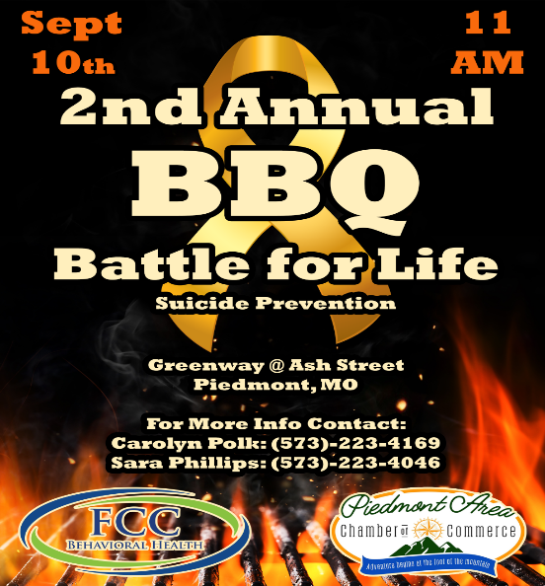

2022 BBQ Battle for Life Food Vendor Registration Form

Concession Name_________________________________________________

Contact Person _______________________________________________

Phone # ______________________

Address _______________________________________

City _______________ State______ Zip_____

Email Address _______________________________________________

Trailer/Tent Size _______________________________________________

Type(s) of Food ______________________________________________

_____ Food vendor fee payment of $50.00 included.

_____ Certificate of liability insurance is included.

_____ I would also like to make a tax-deductible donation for suicide prevention in the amount of $_______.

